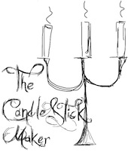

Christmas A-la Carte Menus

£35 per head

Starters:

King prawns, popcorn crust, chilli jam, cauliflower puree

Smoked salmon, cured in gin, with our own festive sourdough

Locally made pork charcuterie plate with pickles

Duck rillettes, blackberry & apple jelly, crisp sourdough bread

Caramelised beetroots, beetroot puree, fennel, goats curd, hazelnuts

Mains:

Venison, glazed beetroots & chicory

Partridge, parsnip cream, pickled elderberries

Rolled and stuffed pork belly, spiced squash puree, quince jam?

Braised short rib of beef, bone marrow, wild mushrooms, sweet onions

Roasted fish of the day with braised fennel, leek & saffron

Sweet Potato, red onion, fennel & chilli tart

Sharing Sides:
Honey and star anise glazed carrots
Roast potatoes with thyme & garlic
Cavalo Nero, sage, bacon, pinenuts
Braised red cabbage with cinnamon and red wine
Leafy green salad

Desserts:

Boozey triffle, cardamom custard, mulled wine jelly

Almond Pannacotta, spiced berries & quince

Chilli & star anise chocolate pudding, roasted apple, hazelnut

Yorkshire style Parkin, whisky & caramel ice cream

